# Exercises: Language Basics

Tasks for exercising from the course ["C Essentials" @ SoftUni](https://softuni.bg/trainings/2940/c-essentials-march-2020).

Test your solutions in the **judge system** here: <https://judge.softuni.bg/Contests/Practice/Index/2233#0>

## "Hello SoftUni!"

Create an application that prints the following message "**Hello SoftUni!**" on the console.

1. Run Code::Blocks.
2. Create new project [File]🡪 [New] 🡪 [Project].

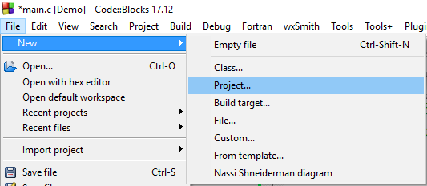

1. From the next window select Console Application and click **Go**:

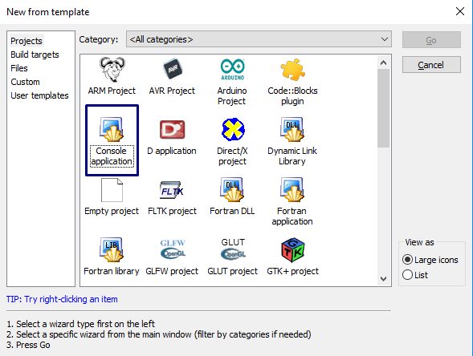

1. On the next window click **Next**, then the following window should appear select the C language and again click **Next**:

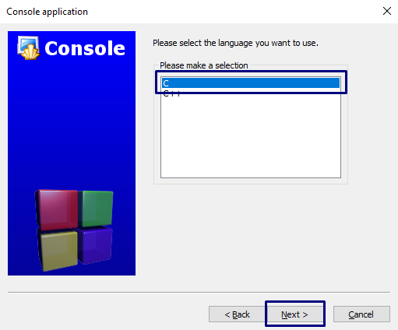

1. Select project title of your own desire, however keep in mind that naming is important it is far better to be something related to the project goal or the problem you are solving instead of some random name. Then again click **Next**:

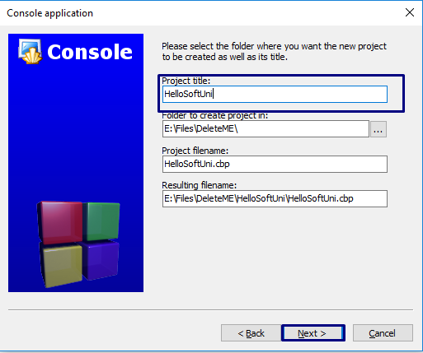

1. On the last window simply click **Finish** and then you should see the following file generated:

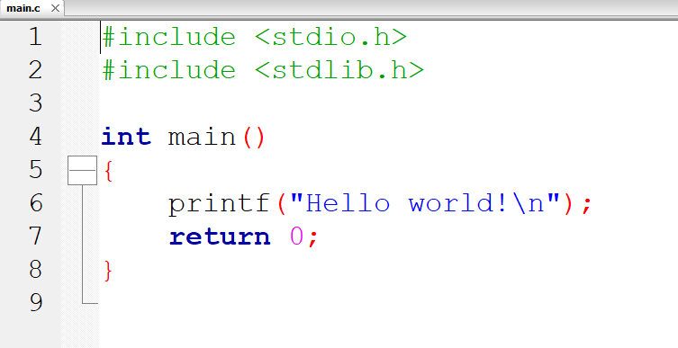

1. **Run the program by pressing** **[F9]**. See what is the result and figure out what you have to change to get the message we wanted printed.

|  |
| --- |
| #include <stdio.h>  #include <stdlib.h>  **int** main()  {  printf("Hello SoftUni!\n");  **return** 0;  } |

1. Here is a little hint of what you have to do:
2. Now after we have covered the basic project creation submit your code inside the judge system:

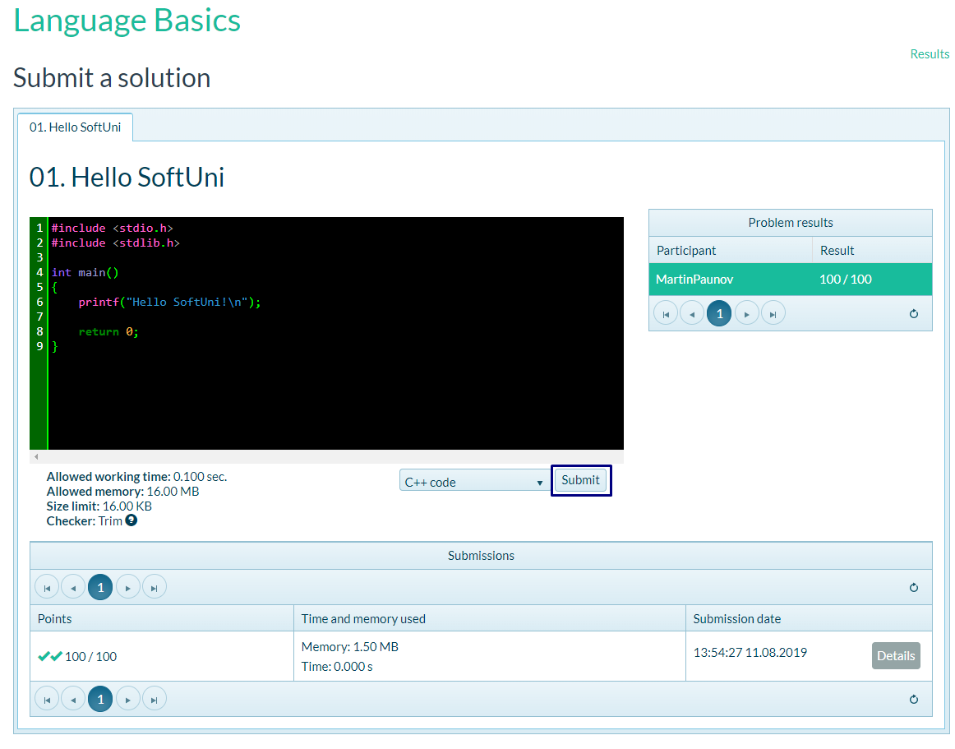

**Those steps you just did are very important, this is how the applications you develop are tested and this is the way you will do it for a long time from now on, so do not get angry if it did not worked out the first time, you have plenty of tries to practice.**

**Anyway, from now on this is how you will submit your code.**

**2. Write Your Name**

Write a program that has only output represented by the following text "My name is **{your_name}**", where you write down your own name.

### Example:

|  |  |
| --- | --- |
| **Input** | **Output** |
|  | My name is Martin |

## Apples Calculator

Create a program that calculates the apples collected form few trees. The thing here is that you have no input data you have some values to work with. Those values are always the same. You have (3) trees, you know that the first tree has a total production of 150 apples, the second one has 142 apples and just to have prime number included the third has 127 apples. Your task is simple save those values inside variables in your program, then calculate the total production of apples and finally print the following output:

**"Apples gathered = {apples_gathered}"**

**You are not allowed to cheat, or are you…?**

## Rectangle Area

So far so easy but things are getting harder already this time it is the good old math we all love.

You will be given input for this task (I know those thing were meant to be for the next time and they are but is okay to look ahead).

You will read two integer numbers representation of two of the sides of rectangle your job is simple to calculate the area and print it on the console.

**Examples:**

|  |  |
| --- | --- |
| **Input** | **Output** |
| 3  17 | Area 51. |
| 7  8 | Area 56. |
| 12  5 | Area 60. |

**Hint: You can use scanf();**

## * Pythagoras Problem

You will read two integer numbers representation of two of the sides of right triangle your job is simple to calculate the hypotenuse and print it on the console.

|  |  |
| --- | --- |
| **Input** | **Output** |
| 3  4 | Hypotenuse is 5. |
| 9  40 | Hypotenuse is 41. |

**Hint: You can use sqrt(), which returns real number as a result plus this function is declared in special header file (remember #Inlcude). It is simple just open google and look for a way to solve that problem. Googling Is part of the job.**